October/November/December Newsletter

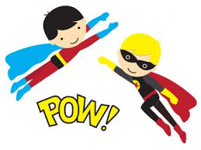 Catalyst 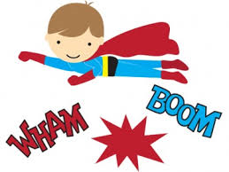

WELCOME BACK TO SCHOOL FOR THE 2014/2015 SCHOOL YEAR!!!
What’s happening this month in our classroom:
This month, students will be introduced to new units of study.
1st and 2nd grade students will be working on “Pastabilities.” They will explore the county of Italy. They will complete a variety of creative and critical thinking activities using pasta. Map and vocabulary activities will broaden the student’s base of general knowledge.
3rd grade students will be exploring the concept of Air Pollution. They will be introduced to the concept of air quality by investigating the composition, properties, atmospheric layers and everyday importance of air. They will also explore the sources and effects of visible and invisible air pollution.
October
22nd “Raising a Reader” Workshop 12:00-1:00 and 5:00-6:00
October 22 Title I information 5:00-6:00
October 30th Junior Fire Marshal Social 3:45-5:00
November
12th Literacy and Math night 5:00-7:00
19th School council/PTO meeting 4:00-5:00
19th Health Festival 5:-00-7:00
December
10th MyOn parent workshop 12:00-1:00 and 5:00-6:00
Visit my website: http://gibbsclassroom.weebly.com

